Q1.

Q2.

Close to AP



5ft from AP



10ft from AP



RSSI gets more negative as AP gets further from robot and the relationship is non linear.

Q3.

Q5.

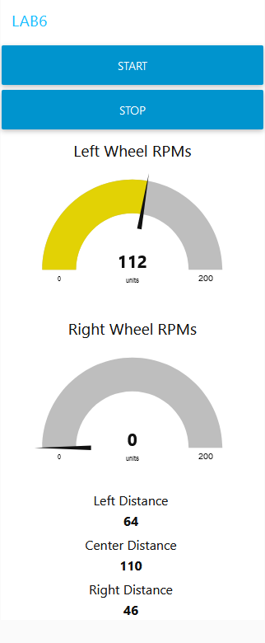My Web App has 2 buttons to stop and start the robot. It has 2 gauges to show the RPMs of the left and right motors. It has 3 text outputs to show the left, center and right distances from the distance sensor.

The hyperlink to my web-app http://172.174.245.35:1880